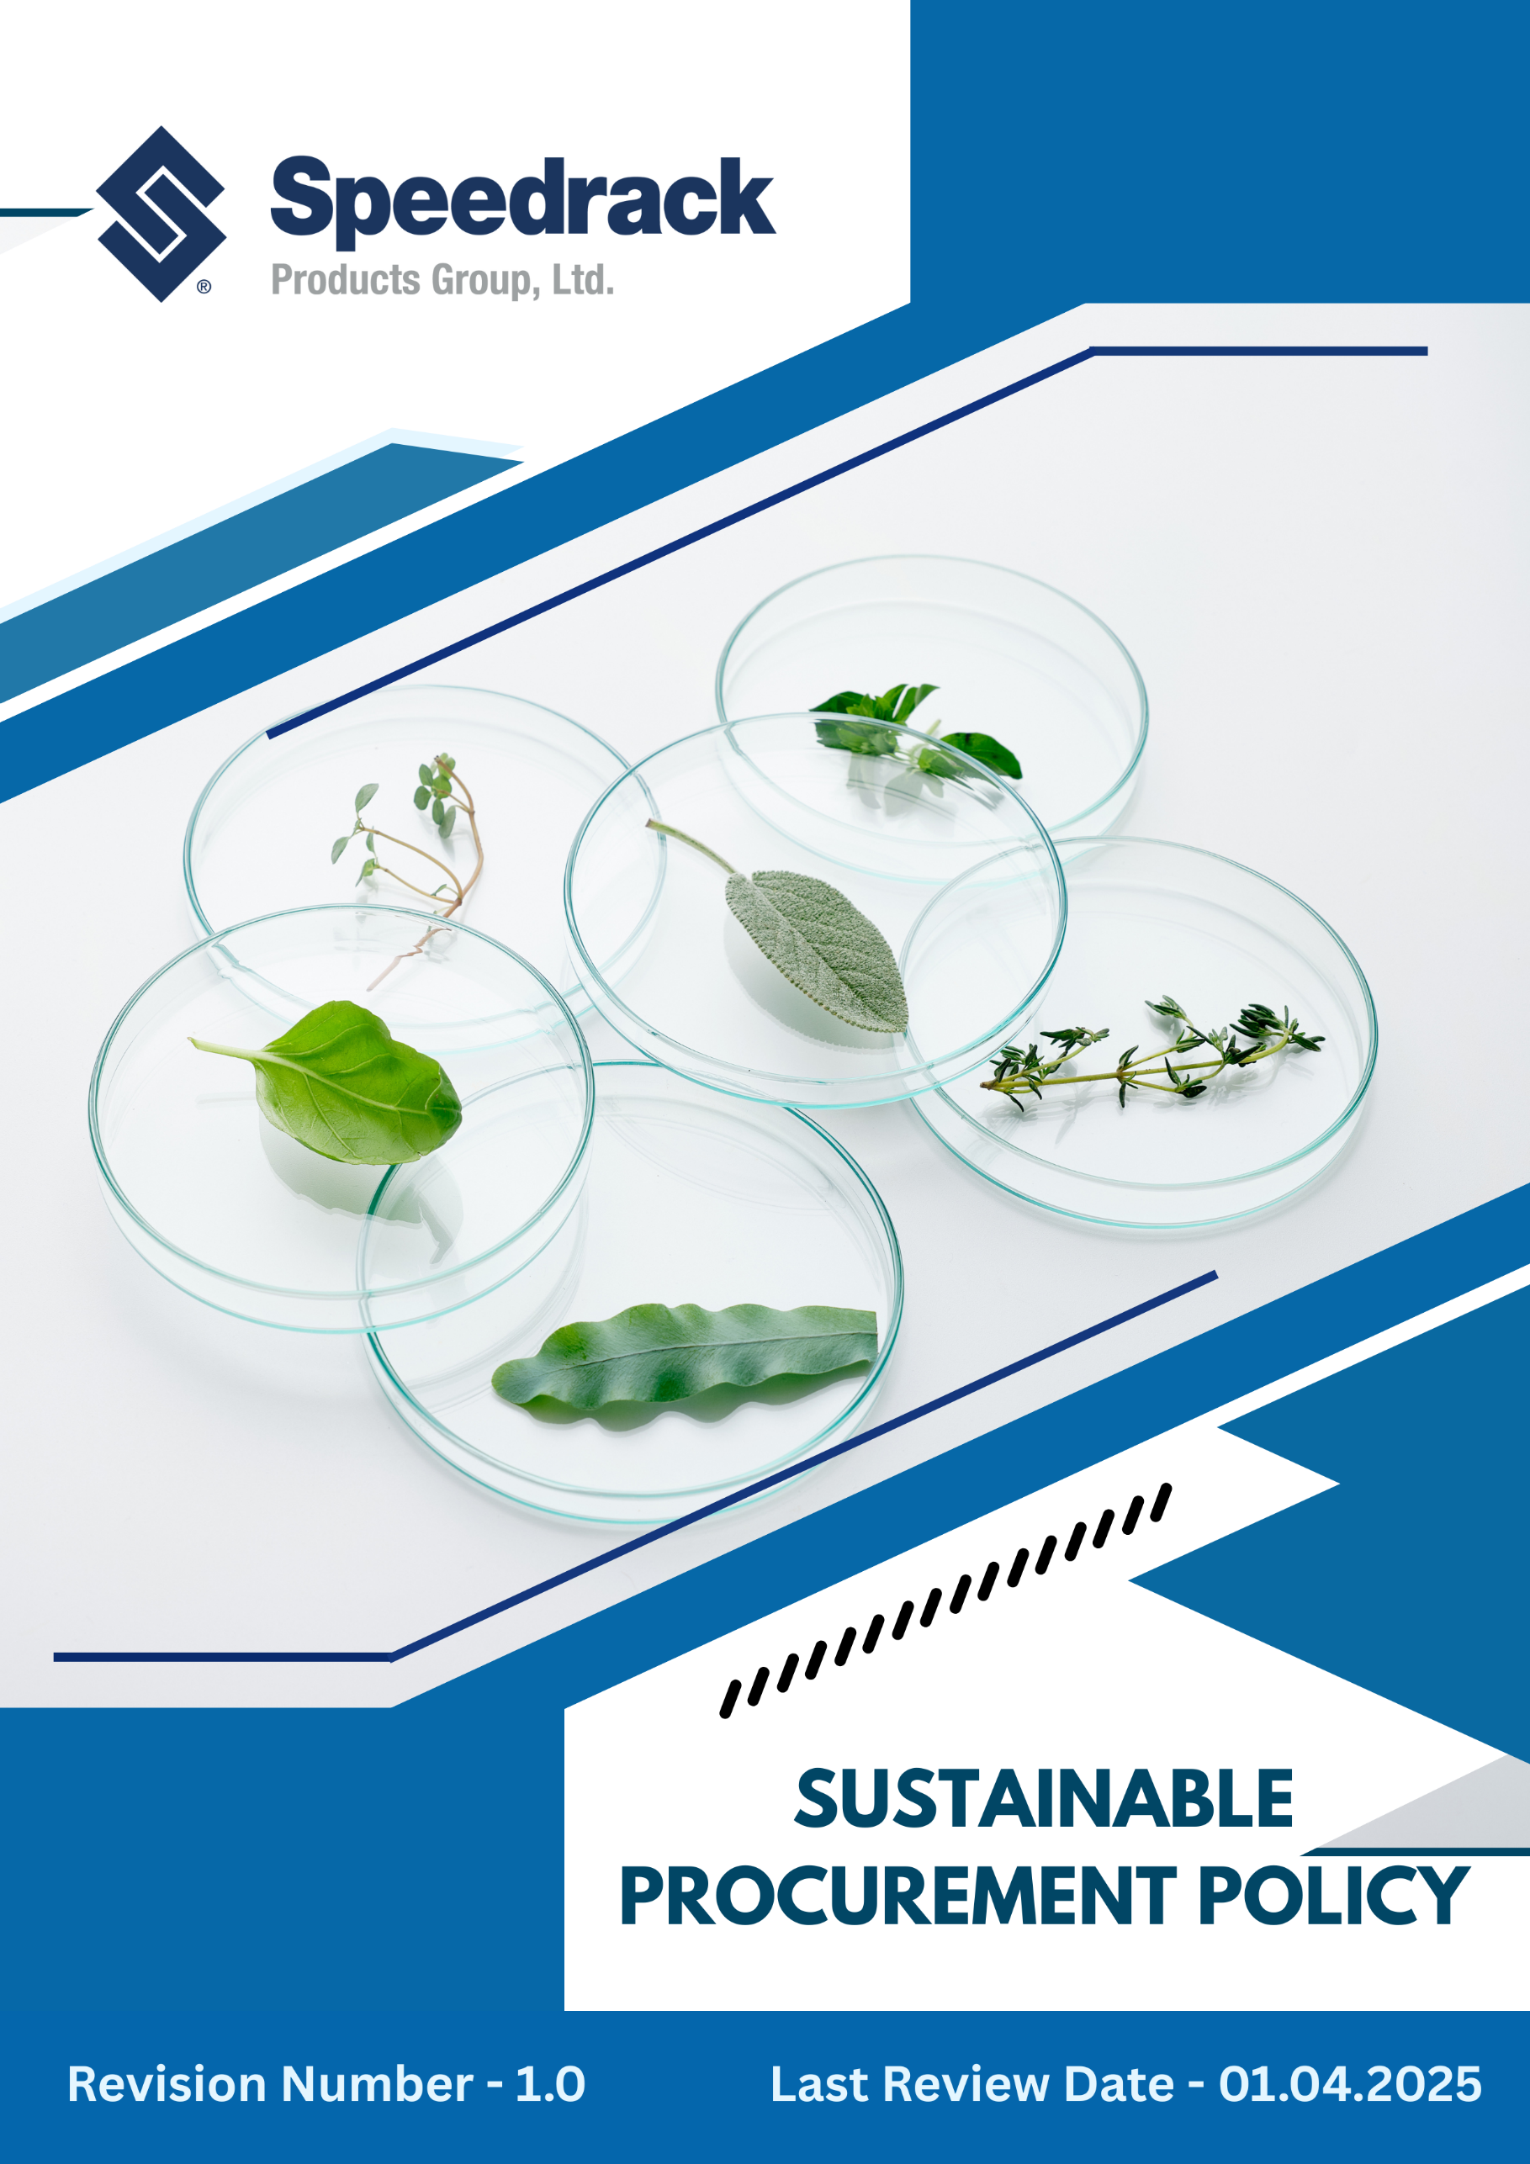
Table of Contents
Introduction 3
Purpose 3
Scope 3
Our Focus Areas 4
Speedrack’s Approach towards the issues 4
Responsibility of this Policy 6
Reporting 7
Continuous Improvement 7
SDGs Covered by This Policy 7
Review Mechanism 7
Employee Acknowledgement Form 9

Introduction
Speedrack Products Group Ltd. is committed to responsible purchasing that prioritizes sustainability, ethical conduct, product quality, health & safety, and long-term business resilience. This Sustainable Procurement Policy defines clear ESG-based expectations for all suppliers, contractors, and business partners to ensure that all procured materials, services, and equipment support Speedrack’s environmental, social, and governance objectives.

Purpose
The purpose of this policy is to:
- Formalize Speedrack’s commitment to environmental stewardship, ethical business conduct, responsible sourcing, and fair labor conditions throughout the supply chain.
- Set criteria and performance requirements for supplier selection, evaluation, auditing, and ongoing collaboration.
- Ensure that procurement decisions consider full lifecycle impacts, safety, durability, resource efficiency, recyclability, and environmental legislation.
- Mitigate operational, legal, environmental, and reputational risks associated with supplier activities.
- Promote long-term partnerships focused on innovation, quality, and continuous improvement.

Scope
This policy applies to all Speedrack locations, business units, suppliers, and employees involved in procurement activities. It covers all purchases of materials, products, and services, and applies to all suppliers, contractors, and partners engaged in Speedrack’s supply chain.
Sr. No | Unit Name | Address
1 | Manufacturing Site | 42 Cole St, Quincy, MI 49082
2 | Manufacturing Site | 3060 S Industrial Dr NW Walker, MI 49544
3 | Corporate Office | 3060 S Industrial Dr NW Walker, MI 49544

Our Focus Areas
Speedrack’s Sustainable Procurement efforts focus on key priority areas that support responsible sourcing, environmental stewardship, and ethical business practices across the supply chain. Our primary focus areas include:
- Environmental Responsibility – Reducing carbon emissions, supporting recycled and resource-efficient materials, minimizing waste, and promoting circular economy principles.
- Ethical Supply Chain & Human Rights – Ensuring suppliers uphold fair labor standards, safe working conditions, and zero tolerance for child or forced labor and discrimination.
- Product Quality, Durability & Safety – Procuring high-quality materials and equipment that comply with international safety, structural, and engineering standards.
- Waste & Emissions Reduction – Encouraging suppliers to adopt clean technologies, optimize packaging, and improve transportation efficiency.
- Supplier Diversity & Local Economic Support – Supporting local suppliers, small businesses, and diverse vendor participation wherever feasible.
- Transparency & Traceability – Requiring suppliers to maintain documentation, material certification, and clear traceability throughout the production process.

Speedrack’s Approach towards the issues
The following commitments and forward-looking targets outline Speedrack’s approach to achieving Sustainable Procurement, in alignment with Speedrack’s 2022 baseline performance data.
- General Sustainability Principles
- Speedrack maintains continuous, structured engagement with suppliers to strengthen collaboration on sustainability performance and ethical sourcing.
- A comprehensive supplier sustainability assessment framework, covering environmental, social, and governance parameters, is fully integrated into procurement operations.
- Sustainability is systematically embedded into all procurement categories through clearly defined product-specific sustainability criteria.
- We aim to provide Code of Conduct including the ESG clauses to all suppliers.
- We aim to ensure that 100% of suppliers read, acknowledge, and formally agree to the Supplier Code of Conduct by 2030.
- We aim to assess at least 10% of its suppliers annually on sustainability performance.
- Speedrack commits to integrating sustainability criteria into 100% of procurement decisions by 2030.
- The company strives to ensure quarterly sustainability performance reporting for 50% of key suppliers by 20300.
- Environmental Responsibility and Stewardship
- Speedrack prioritizes environmentally certified like EMAS, ISO 14001 and other suppliers as a core criterion within its supplier pre-qualification and onboarding framework.
- We aim to promote local sourcing as a key climate-mitigation strategy to minimize transportation-related greenhouse gas (GHG) emissions across its supply chain.
- Circular economy principles are embedded across supplier operations, covering recycling, waste minimization, and material reuse.
- Suppliers are consistently encouraged and supported to transition toward renewable and clean energy sources for both operations and logistics.
- Speedrack aims to source from suppliers that use eco-friendly, recyclable, and biodegradable packaging wherever feasible.
- Speedrack aims to train at least 80% of procurement staff on environmental procurement risks and impacts by 2026, using 2022 as the baseline.
- The company targets a 5% reduction in total supply chain carbon emissions by 2026.
- We plan to ensure that at least 15% of total procurement value is sourced from suppliers holding ISO 14001, EMAS, or equivalent certifications by 2026.
- Labor Practices and Human Rights Compliance
- We aim to embed labor and human rights certifications as a key requirement in its supplier pre-qualification and risk screening process.
- Certifications such as ISO 45001, SA 8000, and equivalent social compliance standards are recognized as preferred indicators of responsible labor practices.
- Company aims to prioritize local suppliers to promote regional development, support community livelihoods, and reduce supply chain emissions.
- Supplier diversity is actively promoted through a formal supplier inclusion program for underrepresented and minority-owned businesses.
- We strive to increase procurement from socially and labor-certified suppliers by 10% by 2030.
- We aim to increase local sourcing by at least 10% by 2030 to support regional economic development and improve livelihoods in surrounding communities.
- We plan to train at least 80% of procurement staff on labor and human rights risks by 2030.
- The company commits to resolving 100% of substantiated supply chain grievances within defined timelines by 2026.

Responsibility of this Policy
- Chief Compliance Office
- Review Policy annually & oversee adherence to the Sustainable Procurement Policy.
- Approve sustainability targets and allocate necessary resources.
- Review supplier performance metrics and ensure alignment with corporate ESG objectives.
- Ensure compliance with all regulatory and industry requirements.
- Procurement & Supply Chain Teams
- Manage supplier selection, onboarding, and ongoing evaluation.
- Integrate environmental, social, and quality standards into contracts and procurement processes.
- Monitor supplier compliance with sustainability and ethical requirements.
- EHS & Quality Assurance Teams
- Conduct periodic audits, inspections, and assessments of suppliers.
- Verify adherence to safety, environmental, and quality standards.
- Provide technical guidance on environmental and safety requirements.
- Suppliers, Contractors, and Partners
- Comply with the Sustainable Procurement Policy and Supplier Code of Conduct.
- Provide accurate documentation, certifications, and sustainability data.
- Cooperate fully during audits, inspections, and performance reviews.
- Implement improvements where gaps or non-compliance are identified.
- All Employees Involved in Procurement
- Identify and report potential sustainability, safety, or ethical risks.
- Participate in training programs on responsible sourcing and compliance.
- Follow procurement procedures that promote environmental, social, and ethical standards.

Reporting
Speedrack will maintain transparent internal reporting mechanisms to track:
- Supplier sustainability performance and compliance history
- Audit results and corrective actions
- Supplier risk ratings and improvement plans

Continuous Improvement
Supplier and internal procurement performance will be regularly reviewed through audits, feedback, and external evaluations to ensure compliance with sustainability and ethical standards. Training, awareness initiatives, and digital tools will support responsible sourcing and supplier engagement. Collaboration with employees and partners will identify improvement opportunities and mitigate risks, while corrective actions will promptly address non-compliance and reinforce responsible practices across the supply chain.

SDGs Covered by This Policy
This Sustainable Procurement Policy covers the following UNSDGs:
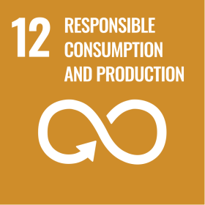

Review Mechanism
The Chief Compliance Officer will annually or as needed review the Sustainable Procurement Policy to assess compliance, identify improvements, and ensure alignment with regulations, industry standards, and ESG objectives. Updates will reflect review outcomes, stakeholder feedback, and best practices, with any significant changes communicated to employees, suppliers, and stakeholders to maintain transparency and clarity.

Effective Date: 01.12.2024
Last Review Date: 01.04.2025 Rev. No. 1.0
Next Review Date: 01.04.2026

Employee Acknowledgement Form
Acknowledgement of having read and understood the Sustainable Procurement Policy is required.
I understand my responsibility to uphold ethical conduct, integrity, transparency, and respect in all professional interactions, and to report any violations promptly and responsibly.
Awareness that compliance with this policy is a mandatory requirement and failure to adhere may result in corrective actions is acknowledged.
By signing below, I agree to support and comply with this policy.

Employee Name: ___________________________________
Department: ________________________________________
Designation: ________________________________________
Signature: ___________________________________________
Date: ______________________________________________

